NAME : SAMARTH GOAVAKAR
USN : ENG25CY1004
ROLL NO : 65
SEC : A

- Perform encryption and decryption of a text file or a random string using DES algorithm with openssl command. [Implement and give a demonstration.]
ANS :
DES Encryption with OpenSSL :
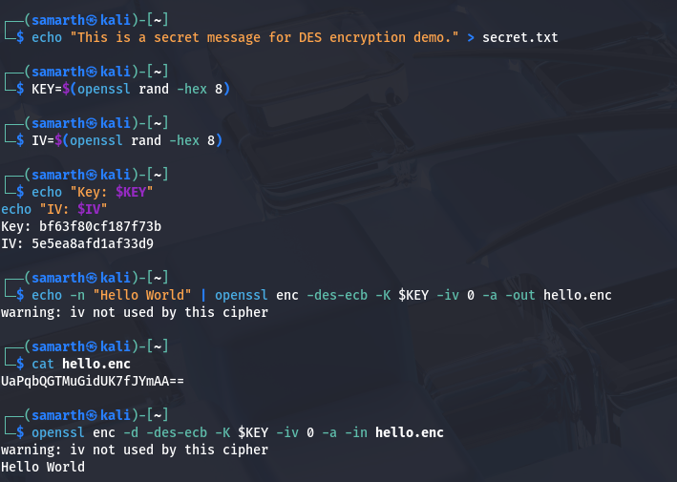
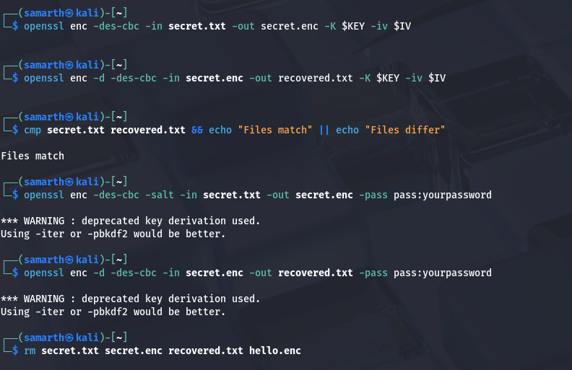
- Write a bash shell script to encrypt 20 files in one shot with the help of openssl command. [Take any encryption algorithm to perform this task.] [Implement and give a demonstration.]
ANS :
Bash Script:

#!/bin/bash
INPUT_DIR="./files_to_encrypt"
OUTPUT_DIR="./encrypted_files"
mkdir -p "$OUTPUT_DIR"
PASSWORD="StrongPassword123"
count=0
for file in "$INPUT_DIR"/*; do
if [ $count -ge 20 ]; then
break
fi
if [ -f "$file" ]; then
filename=$(basename "$file")
outfile="$OUTPUT_DIR/$filename.enc"
openssl enc -aes-256-cbc -salt -in "$file" -out "$outfile" -pass pass:"$PASSWORD"
echo "Encrypted $file -> $outfile"
((count++))
fi
done
echo "Encryption of $count files completed."

Demonstration Steps:
- Create a folder with 20 files:
mkdir files_to_encrypt
for i in {1..20}; do echo "Sample content for file $i" > files_to_encrypt/file$i.txt; done
- Save the above script as encrypt_files.sh and make it executable:
chmod +x encrypt_files.sh
- Run the script:
./encrypt_files.sh
- Check encrypted files in encrypted_files folder:
ls encrypted_files

- Write a brief description (What-Why-How formant) about the following commands:
- df
- fdisk
- dmesg
- crontab
- fsck

ANS :
df
What:
df displays information about disk space usage of mounted file systems.
Why:
It helps you monitor free, used, and available space on your storage devices to manage disk resources effectively.
How:
Run df to see all mounted filesystems. Use options like -h for human-readable sizes (df -h). Example:

fdisk
What:
fdisk is a command-line utility for disk partitioning.
Why:
It allows you to create, delete, and modify partitions on hard drives, essential for preparing disks for use.
How:
Run sudo fdisk /dev/sdX (replace sdX with your disk) to enter interactive mode for partition management. Use commands like n to create and w to write changes.

dmesg
What:
dmesg displays the kernel ring buffer messages.
Why:
It helps in debugging system boot issues or hardware problems by showing kernel event logs.
How:
Run dmesg to view all messages. Use dmesg | less to paginate or dmesg | grep error to filter errors.

crontab
What:
crontab manages scheduled tasks (cron jobs) for users.
Why:
It automates repetitive tasks to run at specified times or intervals.
How:
Run crontab -e to edit your cron jobs. An example cron entry to run a script every day at 5 AM:

fsck
What:
fsck (file system check) verifies and repairs Linux file systems.
Why:
To fix file system errors after improper shutdowns or disk issues, preventing data loss.
How:
Run sudo fsck /dev/sdXN (replace sdXN with partition) to check and fix errors. Usually run on unmounted partitions or in recovery mode.

- Write a step-by-step process to connect two Desktop machines using ssh command. [Implement and give a demonstration.]
ANS :
Step-by-Step: Connect Two Desktop Machines via SSH
This guide connects Machine A (client) to Machine B (server) using SSH on Linux desktops.

Prerequisites
Both machines must be on the same network and have SSH installed:
sudo apt update && sudo apt install openssh-server openssh-client -y

Step 1: Enable & Start SSH Server (Machine B only)
sudo systemctl enable ssh
sudo systemctl start ssh
sudo systemctl status ssh

Step 2: Find IP Addresses
Machine A (client):
ip addr show | grep inet
# Note Machine B's IP (e.g., 192.168.1.100)
Machine B (server):
hostname -I

Step 3: Test Network Connectivity
From Machine A, ping Machine B:
ping 192.168.1.100

Step 4: Connect via SSH (Password Authentication)
From Machine A:
ssh username@192.168.1.100

Success Output:
username@192.168.1.100's password:
Welcome to Ubuntu 22.04 LTS (Kali GNU/Linux)
username@machineB:~$

Step 5: Passwordless SSH (Recommended - Key-Based)
On Machine A (generate key pair):
ssh-keygen -t rsa -b 4096
cat ~/.ssh/id_rsa.pub
On Machine B (add public key):
mkdir -p ~/.ssh && chmod 700 ~/.ssh
nano ~/.ssh/authorized_keys
chmod 600 ~/.ssh/authorized_keys
Test passwordless login from Machine A:
ssh username@192.168.1.100

Complete Live Demonstration
Machine B Setup:
$ sudo systemctl start ssh
$ hostname -I
192.168.1.100
Machine A Connection:
$ ssh kali@192.168.1.100
kali@192.168.1.100's password: [enter password]
kali@machineB:~$ pwd
/home/kali
kali@machineB:~$ whoami
kali
kali@machineB:~$ exit
After Key Setup (passwordless):
$ ssh kali@192.168.1.100
kali@machineB:~$

Troubleshooting
sudo ufw allow ssh
sudo systemctl restart ssh
nmap -sn 192.168.1.0/24

- Write a step-by-step process to transfer a text file from a source machine to a destination machine using ftp command. [Implement and give a demonstration.]
ANS :
Step-by-Step: Transfer Text File via FTP
Source Machine (Client) to Destination Machine (Server) using FTP :

Prerequisites :
Both machines need FTP server/client installed and on the same network.
sudo apt update && sudo apt install vsftpd openssh-server -y

Step 1: Setup FTP Server (Destination Machine ONLY)
sudo systemctl enable vsftpd
sudo systemctl start vsftpd
sudo systemctl status vsftpd
Allow FTP through firewall:
sudo ufw allow 21/tcp
sudo ufw allow 20/tcp

Find Destination Machine IP:
hostname -I

Step 2: Create Test File (Source Machine)
echo "This is confidential data transferred via FTP!" > important.txt
cat important.txt
ls -la important.txt

Step 3: Test FTP Connectivity (Source Machine)
ftp 192.168.1.100

Step 4: Complete FTP Transfer Demonstration
From Source Machine terminal:
$ ftp 192.168.1.100
Connected to 192.168.1.100.
220 (vsFTPd 3.0.3)
Name (192.168.1.100:user): kali
331 Please specify the password.
Password: [enter destination machine password]
230 Login successful.
Remote system type is UNIX.
Using binary mode to transfer files.
ftp> ls
ftp> pwd
ftp> put important.txt
local: important.txt remote: important.txt
227 Entering Passive Mode (192,168,1,100,52,147).
150 Ok to send data.
226 Directory send OK.
ftp> ls
ftp> quit

Step 5: Verify Transfer (Destination Machine)
text
$ ls -la important.txt
-rw-r--r-- 1 kali kali 52 Dec 4 23:08 important.txt
$ cat important.txt
This is confidential data transferred via FTP!

Step 6: Download File (Reverse - Bonus Demo)
From Source Machine:
ftp 192.168.1.100
ftp> get important.txt downloaded.txt
ftp> quit
cat downloaded.txt

Complete Terminal Session Output
Source Machine → FTP Transfer:
$ ftp 192.168.1.100
... [login successful]
ftp> put important.txt
local: important.txt remote: important.txt
227 Entering Passive Mode...
150 Ok to send data.
226 Directory send OK.
47 bytes sent in 0.00 secs (4.70 Kbytes/sec)
ftp> quit

Destination Machine Verification:
text
$ cat important.txt
This is confidential data transferred via FTP!

Troubleshooting
netstat -tlnp | grep :21 # Check if vsftpd listening
sudo systemctl restart vsftpd
sudo chown kali:kali /home/kali/important.txt
chmod 644 important.txt
sudo ufw status
sudo ufw allow 20,21/tcp

